Models Report

## Neat

### Only Boronic Acids

|  |  |  |  |
| --- | --- | --- | --- |
| formula | R.sq | Q.sq | MAE |
| output ~ X.2.9. + dip_z + B5 | 0.8719851 | 0.7041997 | 0.0913893 |
| output ~ X.2.9. + dip_y + B5 | 0.8797651 | 0.6979800 | 0.0858136 |

|  |  |  |  |  |
| --- | --- | --- | --- | --- |
|  | Estimate | Std. Error | t value | Pr(>|t|) |
| (Intercept) | 0.7602560 | 0.0212517 | 35.773953 | 0.0000000 |
| X.2.9. | 0.1854286 | 0.0234177 | 7.918324 | 0.0000072 |
| dip_z | 0.0719108 | 0.0224257 | 3.206622 | 0.0083556 |
| B5 | 0.1186739 | 0.0229895 | 5.162081 | 0.0003123 |

***3 & 5 fold CV***

|  |  |
| --- | --- |
| Q2 | MAE |
| 0.6765074 | 0.1068543 |

|  |  |
| --- | --- |
| Q2 | MAE |
| 0.6995434 | 0.0954343 |

***Top Ranked Full Model***

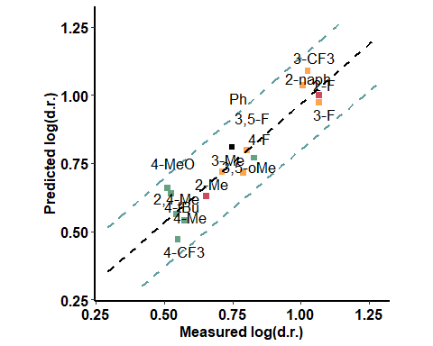

### With Catalyst - Close to the active site

|  |  |  |  |
| --- | --- | --- | --- |
| formula | R.sq | Q.sq | MAE |
| output ~ Dist.14..18. + diff.O16.C17 + L | 0.8064919 | 0.7229366 | 0.0866972 |
| output ~ X.17.18. + Dist.8..14. + NBO.N.19 | 0.8172571 | 0.6967683 | 0.0975522 |

|  |  |  |  |  |
| --- | --- | --- | --- | --- |
|  | Estimate | Std. Error | t value | Pr(>|t|) |
| (Intercept) | 0.7602560 | 0.0261284 | 29.096958 | 0.0000000 |
| Dist.14..18. | 0.1909044 | 0.0334086 | 5.714222 | 0.0001353 |
| diff.O16.C17 | 0.1736214 | 0.0335086 | 5.181403 | 0.0003031 |
| L | -0.0882004 | 0.0271518 | -3.248419 | 0.0077570 |

***3 & 5 fold CV***

|  |  |
| --- | --- |
| Q2 | MAE |
| 0.6163099 | 0.1144414 |

|  |  |
| --- | --- |
| Q2 | MAE |
| 0.6709842 | 0.0979151 |

***Top Ranked Full Model***

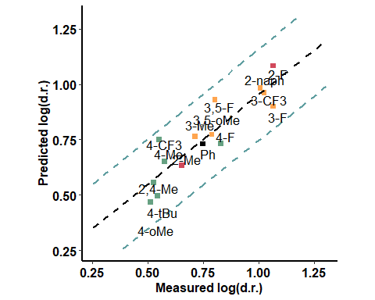

### With Catalyst - far from the active site

|  |  |  |  |
| --- | --- | --- | --- |
| formula | R.sq | Q.sq | MAE |
| output ~ dip_y + diff.C17.O18 + B5 | 0.8527290 | 0.7266616 | 0.0844181 |
| output ~ dip_y + diff.H14.O18 + B5 | 0.8530859 | 0.7177136 | 0.0905937 |

|  |  |  |  |  |
| --- | --- | --- | --- | --- |
|  | Estimate | Std. Error | t value | Pr(>|t|) |
| (Intercept) | 0.7602560 | 0.0227940 | 33.353277 | 0.0000000 |
| dip_y | 0.1038558 | 0.0253244 | 4.101012 | 0.0017564 |
| diff.C17.O18 | -0.1751757 | 0.0251146 | -6.975060 | 0.0000234 |
| B5 | 0.0705326 | 0.0238044 | 2.963002 | 0.0129058 |

***3 & 5 fold CV***

|  |  |
| --- | --- |
| Q2 | MAE |
| 0.6816969 | 0.0994453 |

|  |  |
| --- | --- |
| Q2 | MAE |
| 0.7016755 | 0.0922093 |

***Top Ranked Full Model***

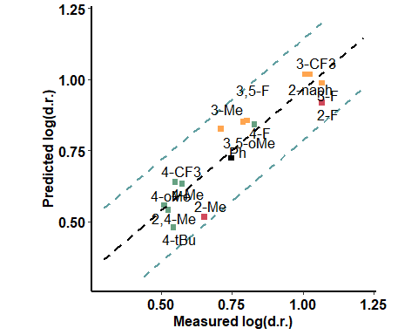

### BA + Pentanone

|  |  |  |  |
| --- | --- | --- | --- |
| formula | R.sq | Q.sq | MAE |
| output ~ X.1.2. + X.17.18. + Dist.17..18. | 0.8314757 | 0.7407062 | 0.0807623 |
| output ~ X.2.3. + X.2.9. + NBO.O.9 | 0.8148084 | 0.7324720 | 0.0748838 |

|  |  |  |  |  |
| --- | --- | --- | --- | --- |
|  | Estimate | Std. Error | t value | Pr(>|t|) |
| (Intercept) | 0.7602560 | 0.0243834 | 31.179262 | 0.0000000 |
| X.1.2. | 0.1329706 | 0.0305909 | 4.346735 | 0.0011617 |
| X.17.18. | 0.9213506 | 0.1753522 | 5.254287 | 0.0002708 |
| Dist.17..18. | 0.9177942 | 0.1751990 | 5.238583 | 0.0002774 |

***3 & 5 fold CV***

|  |  |
| --- | --- |
| Q2 | MAE |
| 0.5954084 | 0.1111396 |

|  |  |
| --- | --- |
| Q2 | MAE |
| 0.6587516 | 0.0944145 |

***Top Ranked Full Model***

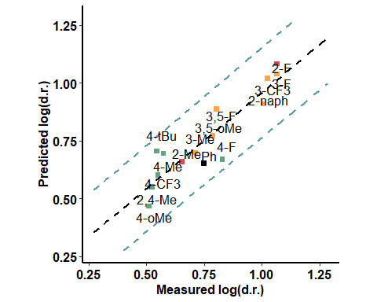

### BA + Aldehyde (pi interaction) - oxygen side

|  |  |  |  |
| --- | --- | --- | --- |
| formula | R.sq | Q.sq | MAE |
| output ~ X.2.9. + diff.O1.B2 + L | 0.7458243 | 0.6309926 | 0.1066979 |
| output ~ X.1.2. + Dist.18..20. + L | 0.7355452 | 0.5825422 | 0.1140823 |

|  |  |  |  |  |
| --- | --- | --- | --- | --- |
|  | Estimate | Std. Error | t value | Pr(>|t|) |
| (Intercept) | 0.7602560 | 0.0299454 | 25.388093 | 0.0000000 |
| X.2.9. | -0.0948999 | 0.0328423 | -2.889565 | 0.0147173 |
| diff.O1.B2 | -0.1591638 | 0.0328524 | -4.844811 | 0.0005150 |
| L | -0.0958739 | 0.0311430 | -3.078506 | 0.0104993 |

***3 & 5 fold CV***

|  |  |
| --- | --- |
| Q2 | MAE |
| 0.5118772 | 0.1429641 |

|  |  |
| --- | --- |
| Q2 | MAE |
| 0.5686433 | 0.1189537 |

***Top Ranked Full Model***

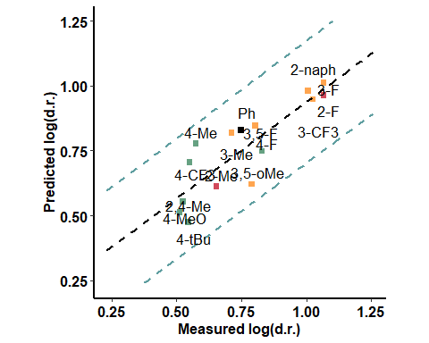

### BA + Aldehyde - pi interaction - hydrogen side

|  |  |  |  |
| --- | --- | --- | --- |
| formula | R.sq | Q.sq | MAE |
| output ~ Dist.10..17. + Total + NBO.B.2 | 0.9183105 | 0.8638877 | 0.0618977 |
| output ~ Total + diff.B2.O9 + diff.H10.O17 | 0.8805636 | 0.8076407 | 0.0715706 |

|  |  |  |  |  |
| --- | --- | --- | --- | --- |
|  | Estimate | Std. Error | t value | Pr(>|t|) |
| (Intercept) | 0.7602560 | 0.0169764 | 44.783077 | 0.00e+00 |
| Dist.10..17. | -0.2547901 | 0.0235603 | -10.814390 | 3.00e-07 |
| Total | -0.1856470 | 0.0232170 | -7.996163 | 6.60e-06 |
| NBO.B.2 | -0.1294256 | 0.0195475 | -6.621078 | 3.76e-05 |

***3 & 5 fold CV***

|  |  |
| --- | --- |
| Q2 | MAE |
| 0.8197333 | 0.0739802 |

|  |  |
| --- | --- |
| Q2 | MAE |
| 0.8477884 | 0.0666105 |

***Top Ranked Full Model***

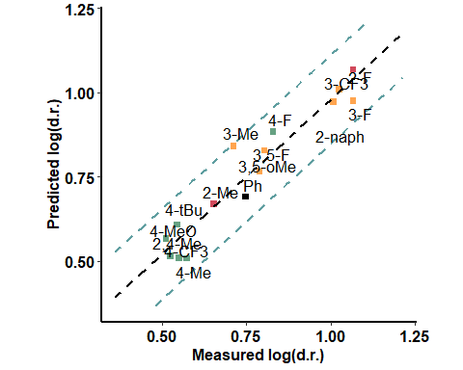

### BA + Aldehyde - H bond - aldehyde side

|  |  |  |  |
| --- | --- | --- | --- |
| formula | R.sq | Q.sq | MAE |
| output ~ para + dip_z + NBO.C.20 | 0.8322566 | 0.7040580 | 0.0891631 |
| output ~ para + dip_z + diff.C18.C20 | 0.8215268 | 0.7007097 | 0.0928397 |

|  |  |  |  |  |
| --- | --- | --- | --- | --- |
|  | Estimate | Std. Error | t value | Pr(>|t|) |
| (Intercept) | 0.7602560 | 0.0243268 | 31.251759 | 0.0000000 |
| para | 0.1248137 | 0.0267514 | 4.665691 | 0.0006873 |
| dip_z | -0.1035397 | 0.0260775 | -3.970461 | 0.0021944 |
| NBO.C.20 | -0.1012133 | 0.0268804 | -3.765316 | 0.0031257 |

***3 & 5 fold CV***

|  |  |
| --- | --- |
| Q2 | MAE |
| 0.6415591 | 0.1071551 |

|  |  |
| --- | --- |
| Q2 | MAE |
| 0.6689537 | 0.0981635 |

***Top Ranked Full Model***

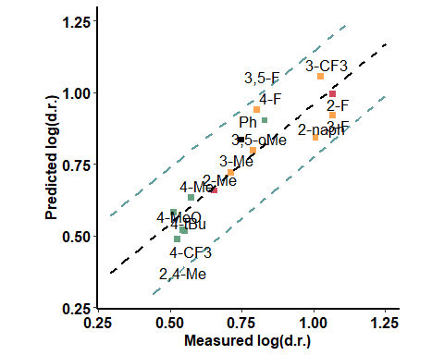

### BA + Aldehyde - H bond - opposite to aldehyde

|  |  |  |  |
| --- | --- | --- | --- |
| formula | R.sq | Q.sq | MAE |
| output ~ Dist.2..9. + dip_z + B1 | 0.7049477 | 0.5485687 | 0.1166106 |
| output ~ X.1.2. + NBO.H.10 + B5 | 0.6769584 | 0.5081417 | 0.1209404 |

|  |  |  |  |  |
| --- | --- | --- | --- | --- |
|  | Estimate | Std. Error | t value | Pr(>|t|) |
| (Intercept) | 0.7602560 | 0.0322636 | 23.563924 | 0.0000000 |
| Dist.2..9. | -0.1555179 | 0.0352004 | -4.418073 | 0.0010318 |
| dip_z | -0.0911710 | 0.0354767 | -2.569885 | 0.0260557 |
| B1 | -0.0824066 | 0.0336808 | -2.446692 | 0.0324356 |

***3 & 5 fold CV***

|  |  |
| --- | --- |
| Q2 | MAE |
| 0.4693024 | 0.1518696 |

|  |  |
| --- | --- |
| Q2 | MAE |
| 0.517652 | 0.124469 |

***Top Ranked Full Model***

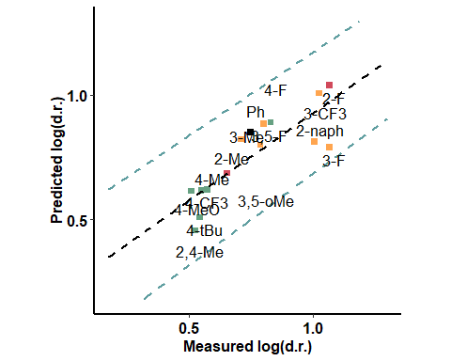

### Enamine - far from the active site

|  |  |  |  |
| --- | --- | --- | --- |
| formula | R.sq | Q.sq | MAE |
| output ~ para + dip_y + diff.C16.O36 | 0.7911133 | 0.6842042 | 0.0923034 |
| output ~ para + Dist.1..2. + dip_y | 0.7939364 | 0.6829495 | 0.0879622 |

|  |  |  |  |  |
| --- | --- | --- | --- | --- |
|  | Estimate | Std. Error | t value | Pr(>|t|) |
| (Intercept) | 0.7602560 | 0.0271468 | 28.005396 | 0.0000000 |
| para | 0.1324083 | 0.0290044 | 4.565117 | 0.0008098 |
| dip_y | 0.0809572 | 0.0284875 | 2.841850 | 0.0160287 |
| diff.C16.O36 | -0.0802905 | 0.0288250 | -2.785447 | 0.0177303 |

***3 & 5 fold CV***

|  |  |
| --- | --- |
| Q2 | MAE |
| 0.5728479 | 0.1203466 |

|  |  |
| --- | --- |
| Q2 | MAE |
| 0.6284218 | 0.1048313 |

***Top Ranked Full Model***

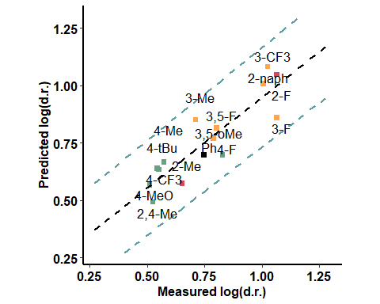

### Enamine - close to the active site

|  |  |  |  |
| --- | --- | --- | --- |
| formula | R.sq | Q.sq | MAE |
| output ~ X.9.16. + Total + diff.O1.B2 | 0.7664625 | 0.5255704 | 0.1235699 |
| output ~ X.16.36. + Total + diff.O1.B2 | 0.7664625 | 0.5255704 | 0.1235699 |

|  |  |  |  |  |
| --- | --- | --- | --- | --- |
|  | Estimate | Std. Error | t value | Pr(>|t|) |
| (Intercept) | 0.7602560 | 0.0287039 | 26.486148 | 0.0000000 |
| X.9.16. | 0.2338055 | 0.0436509 | 5.356263 | 0.0002316 |
| Total | -0.1881195 | 0.0436050 | -4.314174 | 0.0012265 |
| diff.O1.B2 | 0.0928054 | 0.0318789 | 2.911187 | 0.0141589 |

***3 & 5 fold CV***

|  |  |
| --- | --- |
| Q2 | MAE |
| 0.4362723 | 0.1393731 |

|  |  |
| --- | --- |
| Q2 | MAE |
| 0.4894538 | 0.1278434 |

***Top Ranked Full Model***

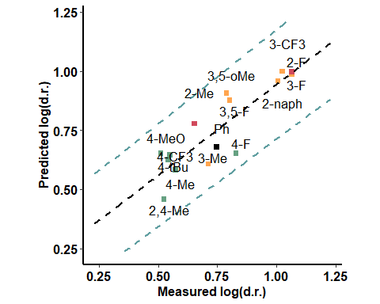

## ACN

### Only Boronic Acids

|  |  |  |  |
| --- | --- | --- | --- |
| formula | R.sq | Q.sq | MAE |
| output ~ X.2.3. + Dist.2..9. + dip_y | 0.8935605 | 0.8215973 | 0.0414026 |
| output ~ X.2.3. + X.9.16. + Dist.2..9. | 0.8792770 | 0.8187999 | 0.0414746 |

|  |  |  |  |  |
| --- | --- | --- | --- | --- |
|  | Estimate | Std. Error | t value | Pr(>|t|) |
| (Intercept) | 0.9445187 | 0.0132770 | 71.139424 | 0.0000000 |
| X.2.3. | -0.0354619 | 0.0153233 | -2.314238 | 0.0409917 |
| Dist.2..9. | -0.1235038 | 0.0162124 | -7.617872 | 0.0000104 |
| dip_y | 0.0307249 | 0.0153868 | 1.996832 | 0.0711893 |

***3 & 5 fold CV***

|  |  |
| --- | --- |
| Q2 | MAE |
| 0.7646598 | 0.0573718 |

|  |  |
| --- | --- |
| Q2 | MAE |
| 0.7911873 | 0.0498054 |

***Top Ranked Full Model***

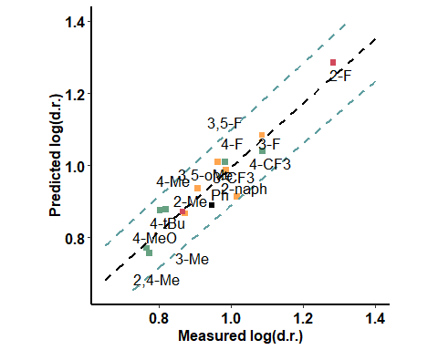

### With Catalyst - Close to the active site

|  |  |  |  |
| --- | --- | --- | --- |
| formula | R.sq | Q.sq | MAE |
| output ~ X.16.17. + Dist.1..8. + diff.O16.C17 | 0.8600127 | 0.7931926 | 0.0545321 |
| output ~ X.8.14. + Dist.14..18. + B1 | 0.8553472 | 0.7896601 | 0.0506718 |

|  |  |  |  |  |
| --- | --- | --- | --- | --- |
|  | Estimate | Std. Error | t value | Pr(>|t|) |
| (Intercept) | 0.9445187 | 0.0152263 | 62.032233 | 0.0000000 |
| X.16.17. | -0.1227704 | 0.0168988 | -7.265025 | 0.0000161 |
| Dist.1..8. | -0.0877933 | 0.0162548 | -5.401069 | 0.0002163 |
| diff.O16.C17 | 0.0442257 | 0.0164047 | 2.695913 | 0.0208081 |

***3 & 5 fold CV***

|  |  |
| --- | --- |
| Q2 | MAE |
| 0.4477399 | 0.2169794 |

|  |  |
| --- | --- |
| Q2 | MAE |
| 0.512109 | 0.137276 |

***Top Ranked Full Model***

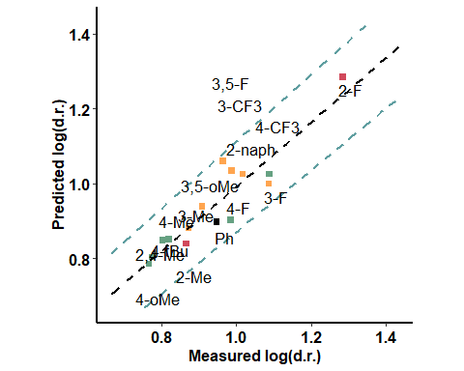

### With Catalyst - far from the active site

|  |  |  |  |
| --- | --- | --- | --- |
| formula | R.sq | Q.sq | MAE |
| output ~ Dist.19..20. + diff.C17.O18 + B5 | 0.9153409 | 0.8689910 | 0.0425448 |
| output ~ Dist.16..17. + Dist.19..20. + diff.N19.H20 | 0.9099579 | 0.8624879 | 0.0461414 |

|  |  |  |  |  |
| --- | --- | --- | --- | --- |
|  | Estimate | Std. Error | t value | Pr(>|t|) |
| (Intercept) | 0.9445187 | 0.0118409 | 79.767307 | 0.0000000 |
| Dist.19..20. | 0.1194359 | 0.0186648 | 6.399000 | 0.0000509 |
| diff.C17.O18 | -0.1903134 | 0.0177404 | -10.727699 | 0.0000004 |
| B5 | -0.0332385 | 0.0134654 | -2.468432 | 0.0312082 |

***3 & 5 fold CV***

|  |  |
| --- | --- |
| Q2 | MAE |
| 0.8304527 | 0.059961 |

|  |  |
| --- | --- |
| Q2 | MAE |
| 0.8541898 | 0.0461192 |

***Top Ranked Full Model***

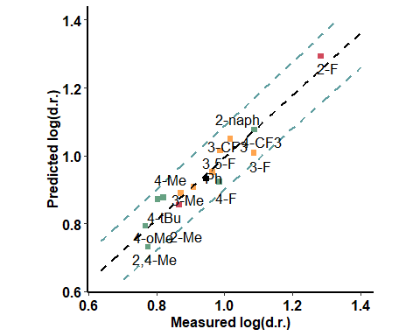

### BA + Pentanone

|  |  |  |  |
| --- | --- | --- | --- |
| formula | R.sq | Q.sq | MAE |
| output ~ Dist.1..2. + dip_x + diff.B2.O9 | 0.8758965 | 0.8147647 | 0.0449457 |
| output ~ dip_x + Total + NBO.O.1 | 0.8718930 | 0.8068999 | 0.0479210 |

|  |  |  |  |  |
| --- | --- | --- | --- | --- |
|  | Estimate | Std. Error | t value | Pr(>|t|) |
| (Intercept) | 0.9445187 | 0.0143364 | 65.882450 | 0.0000000 |
| Dist.1..2. | -0.1630368 | 0.0215539 | -7.564146 | 0.0000111 |
| dip_x | 0.0476885 | 0.0161251 | 2.957410 | 0.0130355 |
| diff.B2.O9 | 0.0364514 | 0.0202817 | 1.797261 | 0.0997708 |

***3 & 5 fold CV***

|  |  |
| --- | --- |
| Q2 | MAE |
| 0.6658149 | 0.0698803 |

|  |  |
| --- | --- |
| Q2 | MAE |
| 0.744246 | 0.057417 |

***Top Ranked Full Model***

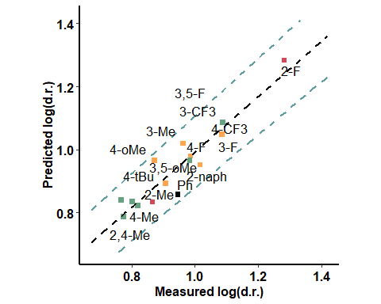

### BA + Aldehyde (pi interaction) - oxygen side

|  |  |  |  |
| --- | --- | --- | --- |
| formula | R.sq | Q.sq | MAE |
| output ~ X.2.9. + Dist.2..9. + B5 | 0.9368757 | 0.8932947 | 0.0362956 |
| output ~ Dist.2..9. + dip_y + B1 | 0.9139520 | 0.8643921 | 0.0429315 |

|  |  |  |  |  |
| --- | --- | --- | --- | --- |
|  | Estimate | Std. Error | t value | Pr(>|t|) |
| (Intercept) | 0.9445187 | 0.0102246 | 92.376896 | 0.0000000 |
| X.2.9. | -0.0485831 | 0.0112237 | -4.328628 | 0.0011973 |
| Dist.2..9. | -0.1253365 | 0.0108604 | -11.540648 | 0.0000002 |
| B5 | -0.0345553 | 0.0113678 | -3.039763 | 0.0112513 |

***3 & 5 fold CV***

|  |  |
| --- | --- |
| Q2 | MAE |
| 0.8696749 | 0.0448942 |

|  |  |
| --- | --- |
| Q2 | MAE |
| 0.8828007 | 0.0394001 |

***Top Ranked Full Model***

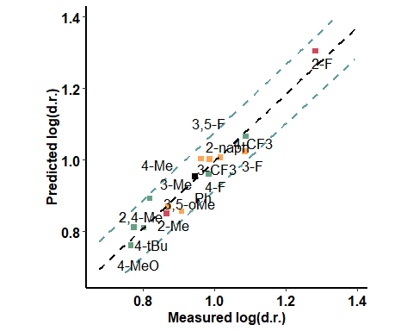

### BA + Aldehyde (pi interaction) - hydrogen side

|  |  |  |  |
| --- | --- | --- | --- |
| formula | R.sq | Q.sq | MAE |
| output ~ NBO.H.16 + diff.O1.H10 + diff.H10.O17 | 0.9561832 | 0.9243700 | 0.0315412 |
| output ~ NBO.O.1 + NBO.H.16 + diff.H10.O17 | 0.9497616 | 0.9119918 | 0.0324338 |

|  |  |  |  |  |
| --- | --- | --- | --- | --- |
|  | Estimate | Std. Error | t value | Pr(>|t|) |
| (Intercept) | 0.9445187 | 0.0085186 | 110.876952 | 0.0000000 |
| NBO.H.16 | -0.0657890 | 0.0170136 | -3.866840 | 0.0026222 |
| diff.O1.H10 | -0.1443473 | 0.0109816 | -13.144510 | 0.0000000 |
| diff.H10.O17 | 0.1730257 | 0.0183219 | 9.443641 | 0.0000013 |

***3 & 5 fold CV***

|  |  |
| --- | --- |
| Q2 | MAE |
| 0.8977793 | 0.0411254 |

|  |  |
| --- | --- |
| Q2 | MAE |
| 0.9114328 | 0.0339986 |

***Top Ranked Full Model***

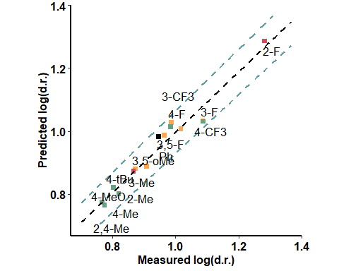

### BA + Aldehyde - H bond - aldehyde side

|  |  |  |  |
| --- | --- | --- | --- |
| formula | R.sq | Q.sq | MAE |
| output ~ NBO.O.9 + diff.H10.O17 + diff.C18.C20 | 0.8246279 | 0.6988750 | 0.0592294 |
| output ~ Dist.9..16. + Total + NBO.O.9 | 0.8130284 | 0.6928567 | 0.0661306 |

|  |  |  |  |  |
| --- | --- | --- | --- | --- |
|  | Estimate | Std. Error | t value | Pr(>|t|) |
| (Intercept) | 0.9445187 | 0.0170423 | 55.421918 | 0.0000000 |
| NBO.O.9 | 0.1657842 | 0.0364231 | 4.551622 | 0.0008279 |
| diff.H10.O17 | -0.2500693 | 0.0510407 | -4.899414 | 0.0004721 |
| diff.C18.C20 | 0.2868322 | 0.0432788 | 6.627546 | 0.0000372 |

***3 & 5 fold CV***

|  |  |
| --- | --- |
| Q2 | MAE |
| 0.6173183 | 0.077972 |

|  |  |
| --- | --- |
| Q2 | MAE |
| 0.6542058 | 0.0676776 |

***Top Ranked Full Model***

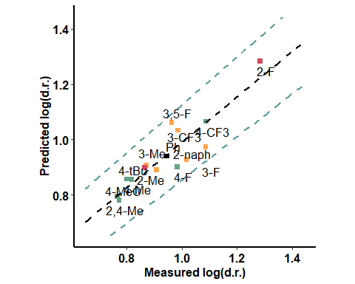

### BA + Aldehyde - H bond - opposite to aldehyde

|  |  |  |  |
| --- | --- | --- | --- |
| formula | R.sq | Q.sq | MAE |
| output ~ NBO.C.18 + diff.O1.H10 + diff.H16.O17 | 0.8573931 | 0.6414726 | 0.0681631 |

|  |  |  |  |  |
| --- | --- | --- | --- | --- |
|  | Estimate | Std. Error | t value | Pr(>|t|) |
| (Intercept) | 0.9445187 | 0.0153681 | 61.459842 | 0.0000000 |
| NBO.C.18 | 0.5466142 | 0.0905860 | 6.034203 | 0.0000850 |
| diff.O1.H10 | -0.1228705 | 0.0363256 | -3.382479 | 0.0061157 |
| diff.H16.O17 | -0.4613203 | 0.0859761 | -5.365679 | 0.0002283 |

***3 & 5 fold CV***

|  |  |
| --- | --- |
| Q2 | MAE |
| 0.6076123 | 0.0900551 |

|  |  |
| --- | --- |
| Q2 | MAE |
| 0.6257414 | 0.0760585 |

***Top Ranked Full Model***

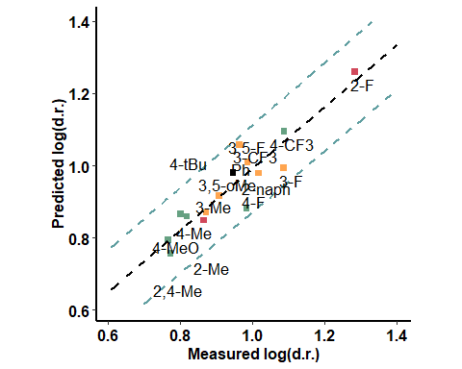

### Enamine - far from the active site

|  |  |  |  |
| --- | --- | --- | --- |
| formula | R.sq | Q.sq | MAE |
| output ~ para + X.2.3. + Dist.1..2. | 0.8489350 | 0.7548529 | 0.0519191 |
| output ~ X.1.2. + Dist.1..2. + B1 | 0.8067027 | 0.7277601 | 0.0562147 |

|  |  |  |  |  |
| --- | --- | --- | --- | --- |
|  | Estimate | Std. Error | t value | Pr(>|t|) |
| (Intercept) | 0.9445187 | 0.0158172 | 59.714511 | 0.0000000 |
| para | 0.0388101 | 0.0192972 | 2.011175 | 0.0694604 |
| X.2.3. | 0.0342529 | 0.0189875 | 1.803966 | 0.0986607 |
| Dist.1..2. | -0.1194747 | 0.0167955 | -7.113504 | 0.0000196 |

***3 & 5 fold CV***

|  |  |
| --- | --- |
| Q2 | MAE |
| 0.6380305 | 0.0704364 |

|  |  |
| --- | --- |
| Q2 | MAE |
| 0.7019644 | 0.0604399 |

***Top Ranked Full Model***

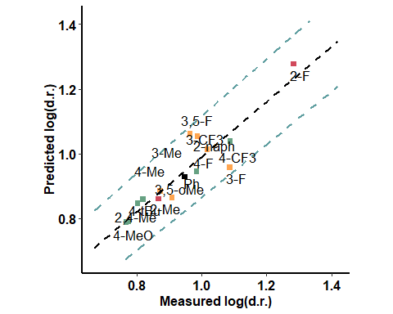

### Enamine - close to the active site

|  |  |  |  |
| --- | --- | --- | --- |
| formula | R.sq | Q.sq | MAE |
| output ~ X.2.3. + Dist.1..10. + diff.O1.H10 | 0.9368997 | 0.8842193 | 0.0410499 |
| output ~ X.2.3. + NBO.H.10 + diff.C16.O36 | 0.9347878 | 0.8555366 | 0.0460048 |

|  |  |  |  |  |
| --- | --- | --- | --- | --- |
|  | Estimate | Std. Error | t value | Pr(>|t|) |
| (Intercept) | 0.9445187 | 0.0102227 | 92.394483 | 0.0000000 |
| X.2.3. | 0.0720869 | 0.0135318 | 5.327223 | 0.0002421 |
| Dist.1..10. | 0.1334003 | 0.0110452 | 12.077639 | 0.0000001 |
| diff.O1.H10 | 0.0675968 | 0.0130683 | 5.172590 | 0.0003073 |

***3 & 5 fold CV***

|  |  |
| --- | --- |
| Q2 | MAE |
| 0.8312262 | 0.0517943 |

|  |  |
| --- | --- |
| Q2 | MAE |
| 0.8564135 | 0.0462081 |

***Top Ranked Full Model***

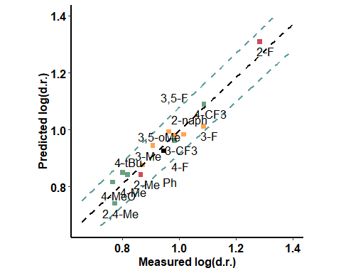

## Methanol

### Only Boronic Acids

|  |  |  |  |
| --- | --- | --- | --- |
| formula | R.sq | Q.sq | MAE |
| output ~ cross + para + Total | 0.6922134 | 0.3986021 | 0.0934931 |
| output ~ X.9.16. + Dist.1..10. + L | 0.6915081 | 0.3948789 | 0.1058145 |

|  |  |  |  |  |
| --- | --- | --- | --- | --- |
|  | Estimate | Std. Error | t value | Pr(>|t|) |
| (Intercept) | 0.7096271 | 0.0250421 | 28.337346 | 0.0000000 |
| cross | 0.1866896 | 0.0533714 | 3.497934 | 0.0049884 |
| para | 0.2248532 | 0.0490043 | 4.588434 | 0.0007795 |
| Total | -0.1476787 | 0.0371808 | -3.971914 | 0.0021889 |

***3 & 5 fold CV***

|  |  |
| --- | --- |
| Q2 | MAE |
| 0.3405423 | 0.1101085 |

|  |  |
| --- | --- |
| Q2 | MAE |
| 0.3618142 | 0.1010866 |

***Top Ranked Full Model***

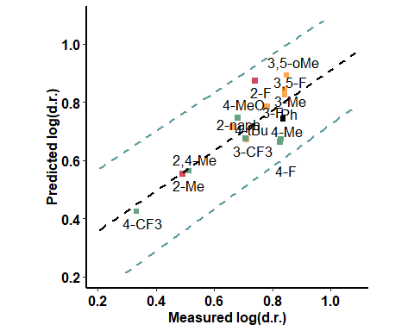

### With Catalyst - Close to the active site

|  |  |  |  |
| --- | --- | --- | --- |
| formula | R.sq | Q.sq | MAE |
| output ~ Dist.1..2. + NBO.B.1 + L | 0.7550323 | 0.5366056 | 0.0850073 |
| output ~ Dist.14..18. + dip_y + diff.O8.H14 | 0.7524695 | 0.4247401 | 0.0773804 |

|  |  |  |  |  |
| --- | --- | --- | --- | --- |
|  | Estimate | Std. Error | t value | Pr(>|t|) |
| (Intercept) | 0.7096271 | 0.0223409 | 31.763592 | 0.0000000 |
| Dist.1..2. | -0.1322018 | 0.0284233 | -4.651181 | 0.0007037 |
| NBO.B.1 | 0.0781880 | 0.0242608 | 3.222809 | 0.0081184 |
| L | -0.1467242 | 0.0295578 | -4.963978 | 0.0004261 |

***3 & 5 fold CV***

|  |  |
| --- | --- |
| Q2 | MAE |
| 0.4489777 | 0.1008164 |

|  |  |
| --- | --- |
| Q2 | MAE |
| 0.496588 | 0.0914699 |

***Top Ranked Full Model***

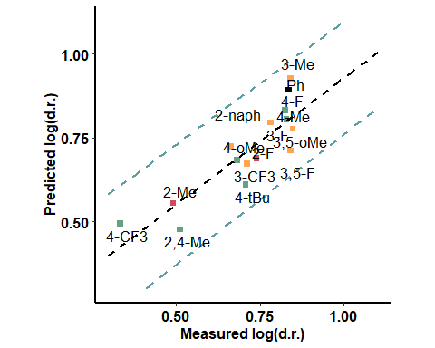

### With Catalyst - far from the active site

|  |  |  |  |
| --- | --- | --- | --- |
| formula | R.sq | Q.sq | MAE |
| output ~ X.1.8. + dip_y + diff.O16.C17 | 0.8272496 | 0.6117842 | 0.0801216 |
| output ~ X.1.8. + dip_y + NBO.O.18 | 0.7782930 | 0.5571560 | 0.0884945 |

|  |  |  |  |  |
| --- | --- | --- | --- | --- |
|  | Estimate | Std. Error | t value | Pr(>|t|) |
| (Intercept) | 0.7096271 | 0.0187610 | 37.824608 | 0.0000000 |
| X.1.8. | 0.1047157 | 0.0200638 | 5.219139 | 0.0002859 |
| dip_y | 0.0981090 | 0.0197640 | 4.964023 | 0.0004261 |
| diff.O16.C17 | -0.0601550 | 0.0199994 | -3.007843 | 0.0119117 |

***3 & 5 fold CV***

|  |  |
| --- | --- |
| Q2 | MAE |
| 0.5515629 | 0.0894694 |

|  |  |
| --- | --- |
| Q2 | MAE |
| 0.589942 | 0.0834045 |

***Top Ranked Full Model***

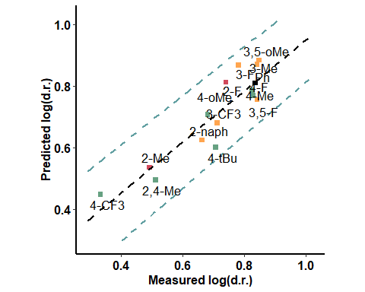

### BA + Pentanone

|  |  |  |  |
| --- | --- | --- | --- |
| formula | R.sq | Q.sq | MAE |
| output ~ Dist.2..3. + dip_y + L | 0.7514926 | 0.5386066 | 0.0898684 |

|  |  |  |  |  |
| --- | --- | --- | --- | --- |
|  | Estimate | Std. Error | t value | Pr(>|t|) |
| (Intercept) | 0.7096271 | 0.0225017 | 31.536564 | 0.0000000 |
| Dist.2..3. | -0.1226959 | 0.0283944 | -4.321130 | 0.0012124 |
| dip_y | 0.0678104 | 0.0240155 | 2.823604 | 0.0165606 |
| L | -0.1090695 | 0.0290876 | -3.749693 | 0.0032116 |

***3 & 5 fold CV***

|  |  |
| --- | --- |
| Q2 | MAE |
| 0.4783471 | 0.0988627 |

|  |  |
| --- | --- |
| Q2 | MAE |
| 0.5008795 | 0.0951922 |

***Top Ranked Full Model***

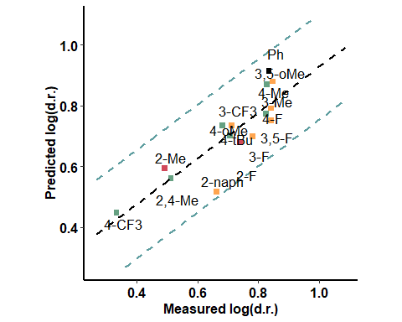

### BA + Aldehyde (pi interaction) - oxygen side

|  |  |  |  |
| --- | --- | --- | --- |
| formula | R.sq | Q.sq | MAE |
| output ~ Dist.2..3. + Dist.18..20. + L | 0.7984201 | 0.6034807 | 0.0730294 |
| output ~ Dist.9..16. + Dist.16..17. + L | 0.7578872 | 0.5670328 | 0.0782136 |

|  |  |  |  |  |
| --- | --- | --- | --- | --- |
|  | Estimate | Std. Error | t value | Pr(>|t|) |
| (Intercept) | 0.7096271 | 0.0202661 | 35.015508 | 0.0000000 |
| Dist.2..3. | -0.1876356 | 0.0314038 | -5.974924 | 0.0000925 |
| Dist.18..20. | 0.1055824 | 0.0244039 | 4.326464 | 0.0012016 |
| L | -0.1778186 | 0.0297389 | -5.979325 | 0.0000920 |

***3 & 5 fold CV***

|  |  |
| --- | --- |
| Q2 | MAE |
| 0.5397727 | 0.0856526 |

|  |  |
| --- | --- |
| Q2 | MAE |
| 0.5732987 | 0.0778355 |

***Top Ranked Full Model***

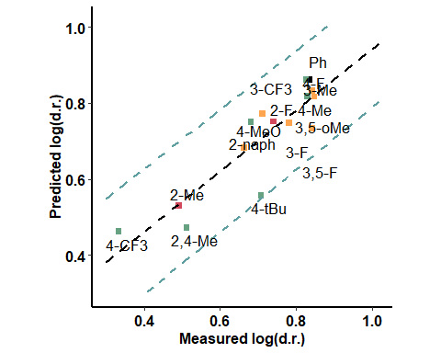

### BA + Aldehyde (pi interaction) - hydrogen side

|  |  |  |  |
| --- | --- | --- | --- |
| formula | R.sq | Q.sq | MAE |
| output ~ X.18.20. + NBO.H.10 + L | 0.8016758 | 0.6515848 | 0.0684132 |
| output ~ X.18.20. + Total + L | 0.7784225 | 0.6172180 | 0.0769768 |

|  |  |  |  |  |
| --- | --- | --- | --- | --- |
|  | Estimate | Std. Error | t value | Pr(>|t|) |
| (Intercept) | 0.7096271 | 0.0201018 | 35.301747 | 0.0000000 |
| X.18.20. | 0.1214244 | 0.0216036 | 5.620573 | 0.0001555 |
| NBO.H.10 | -0.0637230 | 0.0220061 | -2.895699 | 0.0145567 |
| L | -0.1020940 | 0.0227999 | -4.477832 | 0.0009347 |

***3 & 5 fold CV***

|  |  |
| --- | --- |
| Q2 | MAE |
| 0.5830002 | 0.0884932 |

|  |  |
| --- | --- |
| Q2 | MAE |
| 0.6133242 | 0.0741368 |

***Top Ranked Full Model***

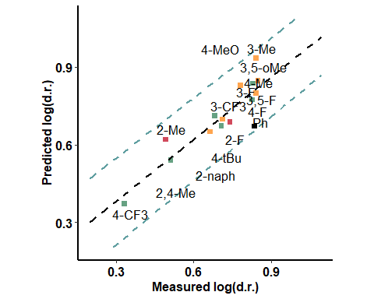

### BA + Aldehyde - H bond - aldehyde side

|  |  |  |  |
| --- | --- | --- | --- |
| formula | R.sq | Q.sq | MAE |
| output ~ Dist.18..20. + NBO.C.18 + L | 0.7703468 | 0.5368018 | 0.0852736 |
| output ~ X.2.9. + Dist.2..3. + L | 0.7577096 | 0.5277069 | 0.0808464 |

|  |  |  |  |  |
| --- | --- | --- | --- | --- |
|  | Estimate | Std. Error | t value | Pr(>|t|) |
| (Intercept) | 0.7096271 | 0.0216313 | 32.805582 | 0.0000000 |
| Dist.18..20. | -0.4975007 | 0.0990250 | -5.023988 | 0.0003876 |
| NBO.C.18 | -0.5707275 | 0.1037945 | -5.498630 | 0.0001866 |
| L | -0.1501622 | 0.0286822 | -5.235379 | 0.0002788 |

***3 & 5 fold CV***

|  |  |
| --- | --- |
| Q2 | MAE |
| 0.4800409 | 0.0963722 |

|  |  |
| --- | --- |
| Q2 | MAE |
| 0.5073712 | 0.090616 |

***Top Ranked Full Model***

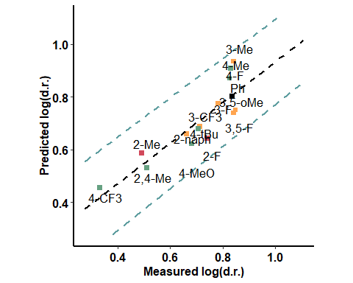

### BA + Aldehyde - H bond - opposite to aldehyde

|  |  |  |  |
| --- | --- | --- | --- |
| formula | R.sq | Q.sq | MAE |
| output ~ Dist.9..16. + diff.O1.B2 + L | 0.7631709 | 0.5907987 | 0.0856327 |
| output ~ X.18.20. + Dist.1..2. + diff.H16.O17 | 0.7649252 | 0.5407058 | 0.0844245 |

|  |  |  |  |  |
| --- | --- | --- | --- | --- |
|  | Estimate | Std. Error | t value | Pr(>|t|) |
| (Intercept) | 0.7096271 | 0.0219666 | 32.304754 | 0.0000000 |
| Dist.9..16. | -0.2161021 | 0.0406119 | -5.321157 | 0.0002444 |
| diff.O1.B2 | -0.1352282 | 0.0398357 | -3.394651 | 0.0059854 |
| L | -0.1208896 | 0.0273489 | -4.420264 | 0.0010281 |

***3 & 5 fold CV***

|  |  |
| --- | --- |
| Q2 | MAE |
| 0.3815917 | 0.1155288 |

|  |  |
| --- | --- |
| Q2 | MAE |
| 0.4630401 | 0.1022524 |

***Top Ranked Full Model***

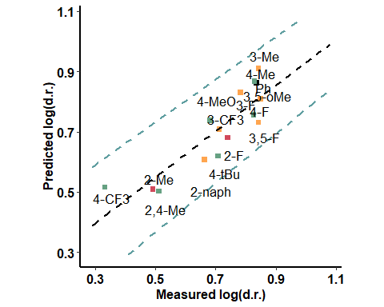

### Enamine - far from the active site

|  |  |  |  |
| --- | --- | --- | --- |
| formula | R.sq | Q.sq | MAE |
| output ~ Dist.10..36. + dip_x + L | 0.7894706 | 0.5283876 | 0.0822182 |
| output ~ X.9.16. + Dist.10..36. + L | 0.7836696 | 0.5004415 | 0.0834403 |

|  |  |  |  |  |
| --- | --- | --- | --- | --- |
|  | Estimate | Std. Error | t value | Pr(>|t|) |
| (Intercept) | 0.7096271 | 0.0207111 | 34.263177 | 0.0000000 |
| Dist.10..36. | 0.1256495 | 0.0234486 | 5.358505 | 0.0002308 |
| dip_x | -0.1169389 | 0.0251268 | -4.653952 | 0.0007006 |
| L | -0.1045710 | 0.0239384 | -4.368340 | 0.0011206 |

***3 & 5 fold CV***

|  |  |
| --- | --- |
| Q2 | MAE |
| 0.4702661 | 0.1159049 |

|  |  |
| --- | --- |
| Q2 | MAE |
| 0.4887238 | 0.1022606 |

***Top Ranked Full Model***

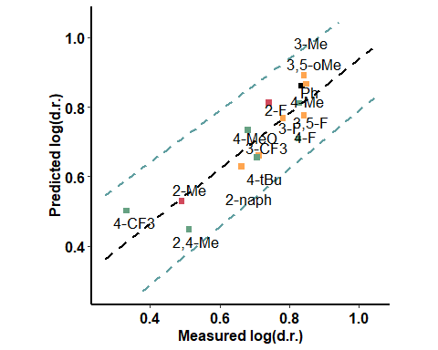

### Enamine - close to the active site

|  |  |  |  |
| --- | --- | --- | --- |
| formula | R.sq | Q.sq | MAE |
| output ~ X.2.9. + NBO.O.36 + L | 0.7860717 | 0.6035341 | 0.0763721 |
| output ~ Dist.2..3. + NBO.B.2 + L | 0.7732674 | 0.5997343 | 0.0761633 |

|  |  |  |  |  |
| --- | --- | --- | --- | --- |
|  | Estimate | Std. Error | t value | Pr(>|t|) |
| (Intercept) | 0.7096271 | 0.0208776 | 33.989898 | 0.0000000 |
| X.2.9. | 0.1073357 | 0.0234353 | 4.580095 | 0.0007902 |
| NBO.O.36 | -0.0823806 | 0.0223876 | -3.679742 | 0.0036275 |
| L | -0.1103054 | 0.0240688 | -4.582928 | 0.0007866 |

***3 & 5 fold CV***

|  |  |
| --- | --- |
| Q2 | MAE |
| 0.5257874 | 0.0880121 |

|  |  |
| --- | --- |
| Q2 | MAE |
| 0.558774 | 0.0827631 |

***Top Ranked Full Model***

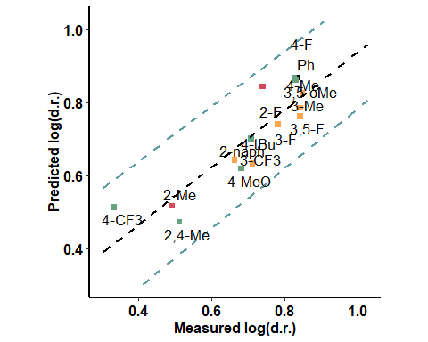

## Chloroform

### Only Boronic Acids

|  |  |  |  |
| --- | --- | --- | --- |
| formula | R.sq | Q.sq | MAE |
| output ~ Dist.1..2. + diff.B2.C3 + B5 | 0.8470181 | 0.7188765 | 0.0873730 |
| output ~ Dist.1..2. + NBO.C.3 + B5 | 0.8464943 | 0.7184720 | 0.0891002 |

|  |  |  |  |  |
| --- | --- | --- | --- | --- |
|  | Estimate | Std. Error | t value | Pr(>|t|) |
| (Intercept) | 0.9516937 | 0.0223869 | 42.511269 | 0.0000000 |
| Dist.1..2. | -0.2543859 | 0.0337924 | -7.527901 | 0.0000116 |
| diff.B2.C3 | 0.2018311 | 0.0360556 | 5.597766 | 0.0001608 |
| B5 | 0.1432921 | 0.0277945 | 5.155413 | 0.0003156 |

***3 & 5 fold CV***

|  |  |
| --- | --- |
| Q2 | MAE |
| 0.5738378 | 0.1079603 |

|  |  |
| --- | --- |
| Q2 | MAE |
| 0.6397147 | 0.0970273 |

***Top Ranked Full Model***

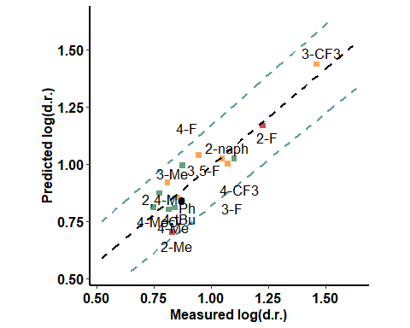

### With Catalyst - Close

|  |  |  |  |
| --- | --- | --- | --- |
| formula | R.sq | Q.sq | MAE |
| output ~ Dist.8..14. + dip_z + Total | 0.9161020 | 0.8347970 | 0.0676771 |
| output ~ Dist.17..18. + NBO.O.18 + diff.N19.H20 | 0.9184669 | 0.8230735 | 0.0673584 |

|  |  |  |  |  |
| --- | --- | --- | --- | --- |
|  | Estimate | Std. Error | t value | Pr(>|t|) |
| (Intercept) | 0.9516937 | 0.0165786 | 57.404791 | 0.0000000 |
| Dist.8..14. | 0.1402622 | 0.0181654 | 7.721413 | 0.0000091 |
| dip_z | 0.0593602 | 0.0183181 | 3.240514 | 0.0078668 |
| Total | -0.0587418 | 0.0175020 | -3.356288 | 0.0064059 |

***3 & 5 fold CV***

|  |  |
| --- | --- |
| Q2 | MAE |
| 0.7466433 | 0.0813729 |

|  |  |
| --- | --- |
| Q2 | MAE |
| 0.8017824 | 0.0727287 |

***Top Ranked Full Model***

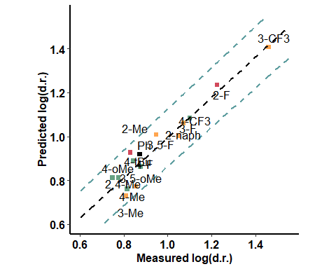

### With Catalyst - far

|  |  |  |  |
| --- | --- | --- | --- |
| formula | R.sq | Q.sq | MAE |
| output ~ Total + NBO.O.16 + diff.B1.C2 | 0.9501665 | 0.9023519 | 0.0470429 |
| output ~ Total + NBO.C.2 + NBO.O.16 | 0.9494356 | 0.8966295 | 0.0496260 |

|  |  |  |  |  |
| --- | --- | --- | --- | --- |
|  | Estimate | Std. Error | t value | Pr(>|t|) |
| (Intercept) | 0.9516937 | 0.0127771 | 74.484101 | 0.0000000 |
| Total | 0.1691442 | 0.0140811 | 12.012146 | 0.0000001 |
| NBO.O.16 | -0.0698816 | 0.0143236 | -4.878771 | 0.0004878 |
| diff.B1.C2 | 0.0419038 | 0.0141754 | 2.956089 | 0.0130663 |

***3 & 5 fold CV***

|  |  |
| --- | --- |
| Q2 | MAE |
| 0.8255142 | 0.0621238 |

|  |  |
| --- | --- |
| Q2 | MAE |
| 0.8685743 | 0.0536012 |

***Top Ranked Full Model***

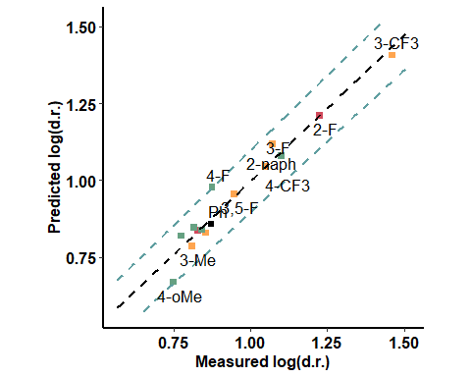

### BA + Pentanone

|  |  |  |  |
| --- | --- | --- | --- |
| formula | R.sq | Q.sq | MAE |
| output ~ Dist.2..9. + diff.B2.C3 + B5 | 0.8810873 | 0.7689940 | 0.0780754 |
| output ~ Dist.2..9. + NBO.C.3 + B5 | 0.8812168 | 0.7679346 | 0.0791693 |

|  |  |  |  |  |
| --- | --- | --- | --- | --- |
|  | Estimate | Std. Error | t value | Pr(>|t|) |
| (Intercept) | 0.9516937 | 0.0197373 | 48.218083 | 0.0000000 |
| Dist.2..9. | -0.2704470 | 0.0309097 | -8.749574 | 0.0000028 |
| diff.B2.C3 | 0.2206265 | 0.0331842 | 6.648551 | 0.0000362 |
| B5 | 0.1134724 | 0.0232557 | 4.879337 | 0.0004874 |

***3 & 5 fold CV***

|  |  |
| --- | --- |
| Q2 | MAE |
| 0.6725197 | 0.0924159 |

|  |  |
| --- | --- |
| Q2 | MAE |
| 0.7231191 | 0.0841402 |

***Top Ranked Full Model***

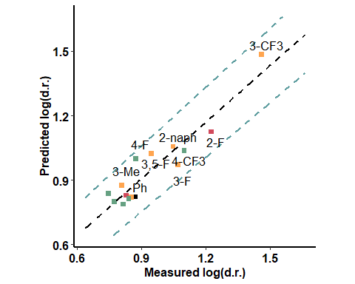

### BA + Aldehyde (pi interaction) - oxygen side

|  |  |  |  |
| --- | --- | --- | --- |
| formula | R.sq | Q.sq | MAE |
| output ~ Dist.17..18. + NBO.C.20 + diff.H16.O17 | 0.9051171 | 0.7532205 | 0.0768778 |
| output ~ Dist.18..20. + Dist.10..17. + NBO.H.10 | 0.8878192 | 0.7508254 | 0.0750426 |

|  |  |  |  |  |
| --- | --- | --- | --- | --- |
|  | Estimate | Std. Error | t value | Pr(>|t|) |
| (Intercept) | 0.9516937 | 0.0176306 | 53.979641 | 0.0e+00 |
| Dist.17..18. | -0.3246620 | 0.0369046 | -8.797328 | 2.6e-06 |
| NBO.C.20 | -0.2777336 | 0.0338176 | -8.212698 | 5.1e-06 |
| diff.H16.O17 | 0.1655450 | 0.0213751 | 7.744749 | 8.9e-06 |

***3 & 5 fold CV***

|  |  |
| --- | --- |
| Q2 | MAE |
| 0.7453368 | 0.0893858 |

|  |  |
| --- | --- |
| Q2 | MAE |
| 0.7574629 | 0.0799352 |

***Top Ranked Full Model***

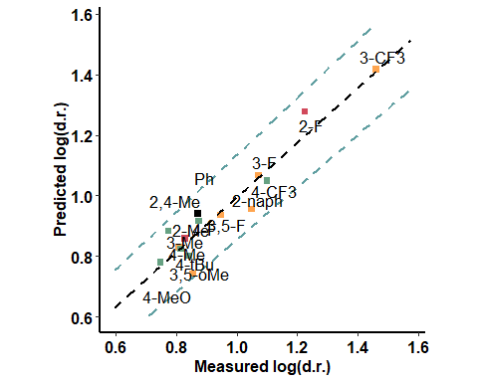

### BA + Aldehyde (pi interaction) - hydrogen side

|  |  |  |  |
| --- | --- | --- | --- |
| formula | R.sq | Q.sq | MAE |
| output ~ Dist.1..10. + diff.B2.O9 + B5 | 0.8171098 | 0.6420217 | 0.0796085 |
| output ~ NBO.H.19 + diff.B2.O9 + B5 | 0.8153299 | 0.6405403 | 0.0937817 |

|  |  |  |  |  |
| --- | --- | --- | --- | --- |
|  | Estimate | Std. Error | t value | Pr(>|t|) |
| (Intercept) | 0.9516937 | 0.0244776 | 38.880229 | 0.0000000 |
| Dist.1..10. | 0.1030092 | 0.0273220 | 3.770194 | 0.0030993 |
| diff.B2.O9 | -0.2235894 | 0.0330667 | -6.761759 | 0.0000311 |
| B5 | 0.1092360 | 0.0315904 | 3.457881 | 0.0053531 |

***3 & 5 fold CV***

|  |  |
| --- | --- |
| Q2 | MAE |
| 0.5443901 | 0.1066903 |

|  |  |
| --- | --- |
| Q2 | MAE |
| 0.6015224 | 0.089799 |

***Top Ranked Full Model***

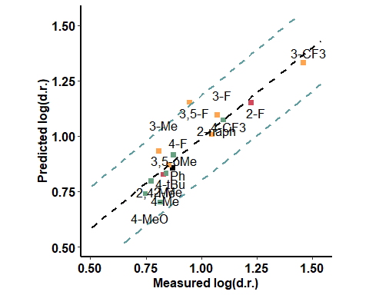

### BA + Aldehyde - H bond - aldehyde side

|  |  |  |  |
| --- | --- | --- | --- |
| formula | R.sq | Q.sq | MAE |
| output ~ X.2.9. + Dist.16..17. + dip_y | 0.8682956 | 0.7800944 | 0.0759574 |
| output ~ X.2.9. + Dist.9..16. + dip_y | 0.8778245 | 0.7788217 | 0.0747310 |

|  |  |  |  |  |
| --- | --- | --- | --- | --- |
|  | Estimate | Std. Error | t value | Pr(>|t|) |
| (Intercept) | 0.9516937 | 0.0207718 | 45.816720 | 0.0000000 |
| X.2.9. | 0.1253820 | 0.0222387 | 5.638000 | 0.0001515 |
| Dist.16..17. | -0.1084500 | 0.0215663 | -5.028678 | 0.0003848 |
| dip_y | 0.1080663 | 0.0221957 | 4.868793 | 0.0004957 |

***3 & 5 fold CV***

|  |  |
| --- | --- |
| Q2 | MAE |
| 0.7425314 | 0.1015883 |

|  |  |
| --- | --- |
| Q2 | MAE |
| 0.7632797 | 0.0843984 |

***Top Ranked Full Model***

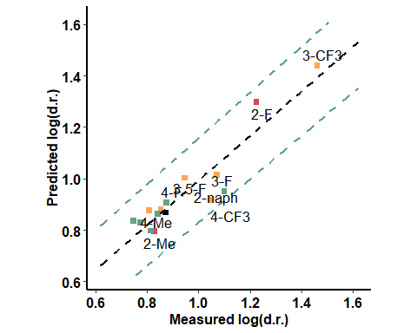

### 

### BA + Aldehyde - H bond - opposite to aldehyde

|  |  |  |  |
| --- | --- | --- | --- |
| formula | R.sq | Q.sq | MAE |
| output ~ X.2.3. + X.17.18. + NBO.H.10 | 0.9345717 | 0.8829876 | 0.0622381 |
| output ~ X.2.3. + X.17.18. + Dist.1..10. | 0.8704286 | 0.7968104 | 0.0822063 |

|  |  |  |  |  |
| --- | --- | --- | --- | --- |
|  | Estimate | Std. Error | t value | Pr(>|t|) |
| (Intercept) | 0.9516937 | 0.0146405 | 65.004157 | 0.00e+00 |
| X.2.3. | -0.1247698 | 0.0180257 | -6.921787 | 2.51e-05 |
| X.17.18. | -0.1598116 | 0.0189528 | -8.432078 | 3.90e-06 |
| NBO.H.10 | 0.2127128 | 0.0175766 | 12.102031 | 1.00e-07 |

***3 & 5 fold CV***

|  |  |
| --- | --- |
| Q2 | MAE |
| 0.6757456 | 0.9079589 |

|  |  |
| --- | --- |
| Q2 | MAE |
| 0.800003 | 0.4067611 |

***Top Ranked Full Model***

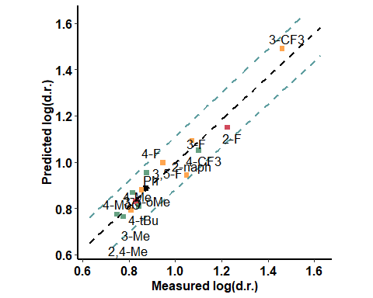

### Enamine - far from the active site

|  |  |  |  |
| --- | --- | --- | --- |
| formula | R.sq | Q.sq | MAE |
| output ~ para + dip_x + Total | 0.9202811 | 0.8504402 | 0.0671754 |
| output ~ para + dip_y + Total | 0.9101539 | 0.8147319 | 0.0720714 |

|  |  |  |  |  |
| --- | --- | --- | --- | --- |
|  | Estimate | Std. Error | t value | Pr(>|t|) |
| (Intercept) | 0.9516937 | 0.0161605 | 58.890246 | 0.0000000 |
| para | 0.0806444 | 0.0178452 | 4.519109 | 0.0008733 |
| dip_x | -0.2482640 | 0.0598172 | -4.150379 | 0.0016154 |
| Total | 0.3861781 | 0.0587006 | 6.578779 | 0.0000398 |

***3 & 5 fold CV***

|  |  |
| --- | --- |
| Q2 | MAE |
| 0.7961489 | 0.0754074 |

|  |  |
| --- | --- |
| Q2 | MAE |
| 0.8240744 | 0.0704558 |

***Top Ranked Full Model***

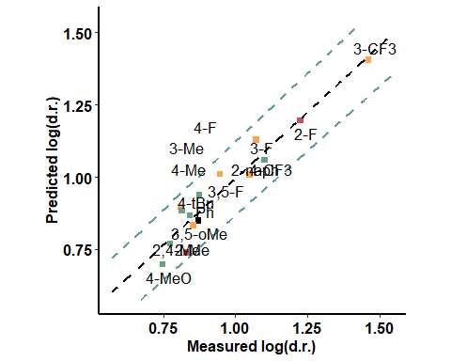

### Enamine - close to the active site

|  |  |  |  |
| --- | --- | --- | --- |
| formula | R.sq | Q.sq | MAE |
| output ~ NBO.C.16 + diff.B2.O9 + diff.N24.C25 | 0.8554631 | 0.6905015 | 0.0855311 |

|  |  |  |  |  |
| --- | --- | --- | --- | --- |
|  | Estimate | Std. Error | t value | Pr(>|t|) |
| (Intercept) | 0.9516937 | 0.0217602 | 43.735566 | 0.0000000 |
| NBO.C.16 | 0.3158147 | 0.0436727 | 7.231407 | 0.0000168 |
| diff.B2.O9 | -0.1407929 | 0.0297186 | -4.737532 | 0.0006119 |
| diff.N24.C25 | -0.2922294 | 0.0371606 | -7.863950 | 0.0000077 |

***3 & 5 fold CV***

|  |  |
| --- | --- |
| Q2 | MAE |
| 0.5221028 | 0.1197347 |

|  |  |
| --- | --- |
| Q2 | MAE |
| 0.5996629 | 0.1036941 |

***Top Ranked Full Model***

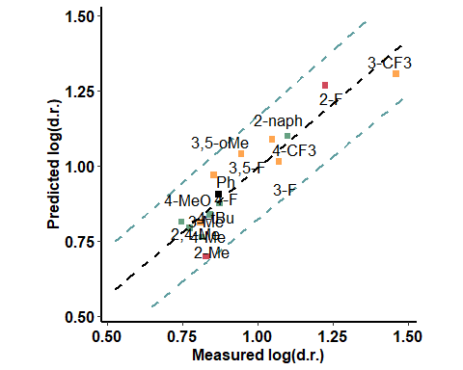

## Hexane

### Only Boronic Acids

|  |  |  |  |
| --- | --- | --- | --- |
| formula | R.sq | Q.sq | MAE |
| output ~ X.2.9. + Dist.2..3. + B5 | 0.8755476 | 0.7691076 | 0.0643666 |
| output ~ X.2.9. + Dist.9..16. + B5 | 0.8566010 | 0.6682341 | 0.0820453 |

|  |  |  |  |  |
| --- | --- | --- | --- | --- |
|  | Estimate | Std. Error | t value | Pr(>|t|) |
| (Intercept) | 0.5902181 | 0.0183355 | 32.189883 | 0.0000000 |
| X.2.9. | 0.1460368 | 0.0210299 | 6.944243 | 0.0000244 |
| Dist.2..3. | -0.0630844 | 0.0217923 | -2.894798 | 0.0145802 |
| B5 | 0.1682191 | 0.0223758 | 7.517920 | 0.0000117 |

***3 & 5 fold CV***

|  |  |
| --- | --- |
| Q2 | MAE |
| 0.666408 | 0.0827982 |

|  |  |
| --- | --- |
| Q2 | MAE |
| 0.7185957 | 0.0722703 |

***Top Ranked Full Model***

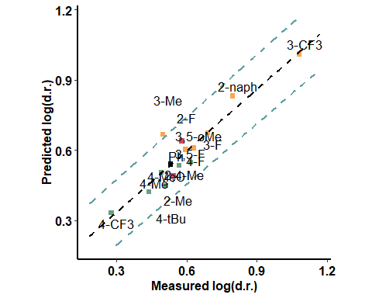

### With Catalyst - Close to the active site

|  |  |  |  |
| --- | --- | --- | --- |
| formula | R.sq | Q.sq | MAE |
| output ~ Total + diff.C17.O18 + B5 | 0.7809091 | 0.5620645 | 0.0942857 |
| output ~ Dist.1..2. + Dist.8..14. + B5 | 0.7764460 | 0.5451110 | 0.0913185 |

|  |  |  |  |  |
| --- | --- | --- | --- | --- |
|  | Estimate | Std. Error | t value | Pr(>|t|) |
| (Intercept) | 0.5902181 | 0.0243278 | 24.261006 | 0.0000000 |
| Total | -0.1259711 | 0.0297082 | -4.240286 | 0.0013882 |
| diff.C17.O18 | -0.0816847 | 0.0292958 | -2.788276 | 0.0176409 |
| B5 | 0.0828415 | 0.0262542 | 3.155356 | 0.0091544 |

***3 & 5 fold CV***

|  |  |
| --- | --- |
| Q2 | MAE |
| 0.4724348 | 0.1141425 |

|  |  |
| --- | --- |
| Q2 | MAE |
| 0.5123817 | 0.101973 |

***Top Ranked Full Model***

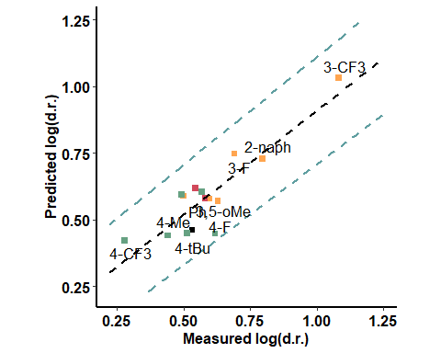

### With Catalyst - far from the active site

|  |  |  |  |
| --- | --- | --- | --- |
| formula | R.sq | Q.sq | MAE |
| output ~ Dist.1..2. + Total + B5 | 0.7616516 | 0.565349 | 0.0881043 |

|  |  |  |  |  |
| --- | --- | --- | --- | --- |
|  | Estimate | Std. Error | t value | Pr(>|t|) |
| (Intercept) | 0.5902181 | 0.0253745 | 23.260277 | 0.0000000 |
| Dist.1..2. | -0.1008379 | 0.0352923 | -2.857220 | 0.0155940 |
| Total | 0.1294074 | 0.0333966 | 3.874872 | 0.0025861 |
| B5 | 0.1228454 | 0.0288244 | 4.261853 | 0.0013388 |

***3 & 5 fold CV***

|  |  |
| --- | --- |
| Q2 | MAE |
| 0.4813282 | 0.1061982 |

|  |  |
| --- | --- |
| Q2 | MAE |
| 0.5275744 | 0.0953394 |

***Top Ranked Full Model***

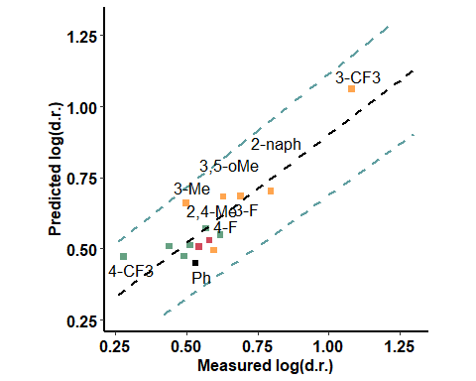

### BA + Aldehyde (pi interaction) - oxygen side

|  |  |  |  |
| --- | --- | --- | --- |
| formula | R.sq | Q.sq | MAE |
| output ~ X.2.9. + X.1.10. + X.18.19. | 0.7995523 | 0.6454449 | 0.1756751 |
| output ~ X.18.19. + X.18.20. + diff.C18.C20 | 0.7632680 | 0.5832786 | 0.2354729 |

|  |  |  |  |  |
| --- | --- | --- | --- | --- |
|  | Estimate | Std. Error | t value | Pr(>|t|) |
| (Intercept) | 0.5902181 | 0.0232698 | 25.364159 | 0.0000000 |
| X.2.9. | -0.0525346 | 0.0248238 | -2.116300 | 0.0579406 |
| X.1.10. | -0.0789994 | 0.0255239 | -3.095115 | 0.0101926 |
| X.18.19. | 0.1670208 | 0.0257086 | 6.496683 | 0.0000445 |

***3 & 5 fold CV***

|  |  |
| --- | --- |
| Q2 | MAE |
| 0.568998 | 1.692854 |

|  |  |
| --- | --- |
| Q2 | MAE |
| 0.5710617 | 1.291109 |

***Top Ranked Full Model***

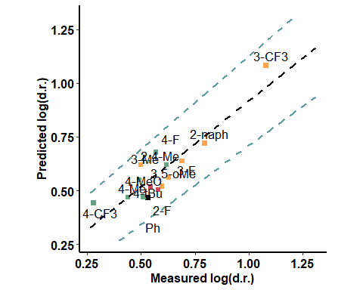

### BA + Aldehyde (pi interaction) - hydrogen side

|  |  |  |  |
| --- | --- | --- | --- |
| formula | R.sq | Q.sq | MAE |
| output ~ Dist.9..16. + Dist.17..18. + NBO.C.20 | 0.8320009 | 0.6121787 | 0.0894207 |
| output ~ Dist.9..16. + Dist.17..18. + diff.C18.C20 | 0.8177483 | 0.6027992 | 0.0856343 |

|  |  |  |  |  |
| --- | --- | --- | --- | --- |
|  | Estimate | Std. Error | t value | Pr(>|t|) |
| (Intercept) | 0.5902181 | 0.0213032 | 27.705600 | 0.0000000 |
| Dist.9..16. | -0.2378390 | 0.0447972 | -5.309241 | 0.0002489 |
| Dist.17..18. | 0.5739637 | 0.0792099 | 7.246111 | 0.0000165 |
| NBO.C.20 | 0.3993029 | 0.0566846 | 7.044294 | 0.0000214 |

***3 & 5 fold CV***

|  |  |
| --- | --- |
| Q2 | MAE |
| 0.5765431 | 0.0956017 |

|  |  |
| --- | --- |
| Q2 | MAE |
| 0.6045818 | 0.089529 |

***Top Ranked Full Model***

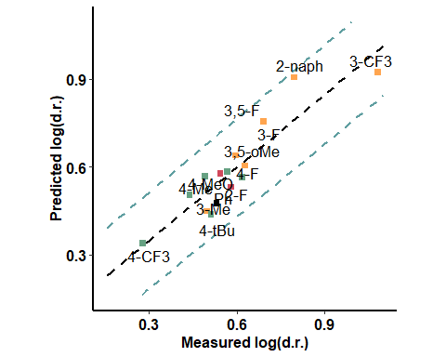

### BA + Aldehyde - H bond - aldehyde side

|  |  |  |  |
| --- | --- | --- | --- |
| formula | R.sq | Q.sq | MAE |
| output ~ para + dip_z + B5 | 0.6540133 | 0.3975334 | 0.0977147 |
| output ~ Dist.2..3. + NBO.C.20 + B5 | 0.6864446 | 0.3596414 | 0.1086377 |

|  |  |  |  |  |
| --- | --- | --- | --- | --- |
|  | Estimate | Std. Error | t value | Pr(>|t|) |
| (Intercept) | 0.5902181 | 0.0305718 | 19.305956 | 0.0000000 |
| para | 0.0800794 | 0.0331397 | 2.416415 | 0.0342235 |
| dip_z | -0.0586576 | 0.0343380 | -1.708241 | 0.1156203 |
| B5 | 0.0874714 | 0.0340409 | 2.569600 | 0.0260690 |

***3 & 5 fold CV***

|  |  |
| --- | --- |
| Q2 | MAE |
| 0.3454542 | 0.1211554 |

|  |  |
| --- | --- |
| Q2 | MAE |
| 0.3623049 | 0.1099832 |

***Top Ranked Full Model***

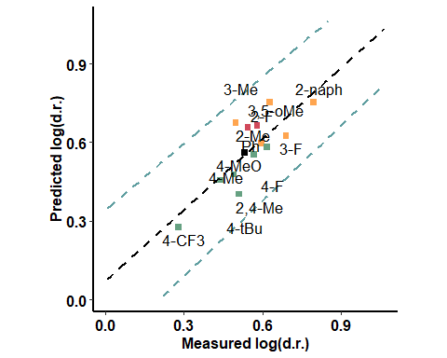

### BA + Aldehyde - H bond - opposite to aldehyde

|  |  |  |  |
| --- | --- | --- | --- |
| formula | R.sq | Q.sq | MAE |
| output ~ X.2.3. + diff.C18.H19 + B5 | 0.8033539 | 0.6259376 | 0.0880591 |

|  |  |  |  |  |
| --- | --- | --- | --- | --- |
|  | Estimate | Std. Error | t value | Pr(>|t|) |
| (Intercept) | 0.5902181 | 0.0230481 | 25.608157 | 0.0000000 |
| X.2.3. | -0.0658658 | 0.0246705 | -2.669820 | 0.0218010 |
| diff.C18.H19 | -0.1029966 | 0.0254818 | -4.041973 | 0.0019419 |
| B5 | 0.1640537 | 0.0259575 | 6.320084 | 0.0000568 |

***3 & 5 fold CV***

|  |  |
| --- | --- |
| Q2 | MAE |
| 0.4603351 | 0.1200071 |

|  |  |
| --- | --- |
| Q2 | MAE |
| 0.5333689 | 0.1026862 |

***Top Ranked Full Model***

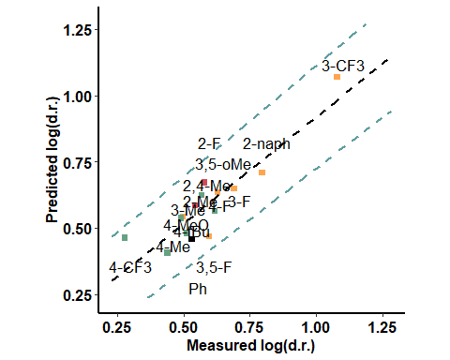

### Enamine - far from the active site

|  |  |  |  |
| --- | --- | --- | --- |
| formula | R.sq | Q.sq | MAE |
| output ~ X.1.10. + dip_z + B5 | 0.6959192 | 0.4826160 | 0.0944714 |
| output ~ Dist.1..10. + dip_z + B5 | 0.7020307 | 0.4816768 | 0.0948664 |

|  |  |  |  |  |
| --- | --- | --- | --- | --- |
|  | Estimate | Std. Error | t value | Pr(>|t|) |
| (Intercept) | 0.5902181 | 0.0286606 | 20.593327 | 0.0000000 |
| X.1.10. | 0.0541858 | 0.0311904 | 1.737260 | 0.1102207 |
| dip_z | -0.0984117 | 0.0315416 | -3.120057 | 0.0097490 |
| B5 | 0.1557786 | 0.0330449 | 4.714155 | 0.0006354 |

***3 & 5 fold CV***

|  |  |
| --- | --- |
| Q2 | MAE |
| 0.297223 | 0.1537918 |

|  |  |
| --- | --- |
| Q2 | MAE |
| 0.3472259 | 0.1283395 |

***Top Ranked Full Model***

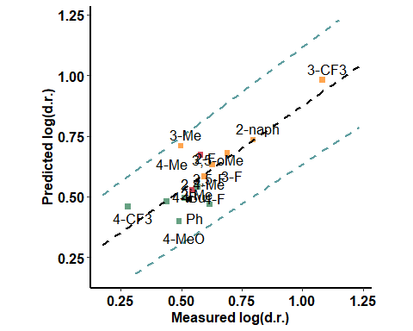

### Enamine - close to the active site

|  |  |  |  |
| --- | --- | --- | --- |
| formula | R.sq | Q.sq | MAE |
| output ~ Dist.10..36. + dip_z + NBO.C.16 | 0.6564753 | 0.4011530 | 0.0908784 |
| output ~ dip_x + NBO.C.16 + NBO.C.25 | 0.7055401 | 0.3117577 | 0.1080938 |

|  |  |  |  |  |
| --- | --- | --- | --- | --- |
|  | Estimate | Std. Error | t value | Pr(>|t|) |
| (Intercept) | 0.5902181 | 0.0304628 | 19.375013 | 0.0000000 |
| Dist.10..36. | 0.1667968 | 0.0421312 | 3.958982 | 0.0022380 |
| dip_z | 0.0808861 | 0.0320510 | 2.523668 | 0.0282903 |
| NBO.C.16 | 0.1559673 | 0.0420735 | 3.707017 | 0.0034591 |

***3 & 5 fold CV***

|  |  |
| --- | --- |
| Q2 | MAE |
| 0.2949039 | 0.1317234 |

|  |  |
| --- | --- |
| Q2 | MAE |
| 0.3310653 | 0.1075782 |

***Top Ranked Full Model***

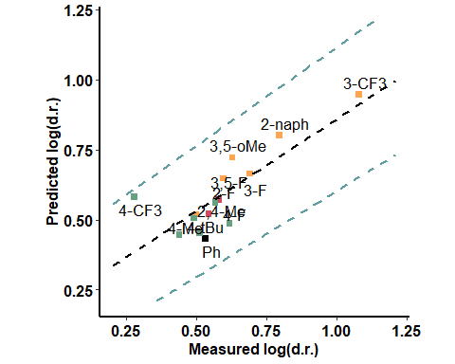

## Hexane - against ee

### Only Boronic Acids

|  |  |  |  |
| --- | --- | --- | --- |
| formula | R.sq | Q.sq | MAE |
| output ~ NBO.H.16 + diff.B2.C3 + B5 | 0.8092831 | 0.5969891 | 0.1564650 |
| output ~ NBO.C.3 + NBO.H.16 + B5 | 0.8061288 | 0.5901086 | 0.1563283 |

|  |  |  |  |  |
| --- | --- | --- | --- | --- |
|  | Estimate | Std. Error | t value | Pr(>|t|) |
| (Intercept) | 0.7999364 | 0.0408109 | 19.601048 | 0.00e+00 |
| NBO.H.16 | 0.3526279 | 0.0586513 | 6.012276 | 8.77e-05 |
| diff.B2.C3 | 0.2913971 | 0.0628399 | 4.637133 | 7.20e-04 |
| B5 | 0.2346225 | 0.0476628 | 4.922548 | 4.55e-04 |

***3 & 5 fold CV***

|  |  |
| --- | --- |
| Q2 | MAE |
| 0.5444704 | 0.1791977 |

|  |  |
| --- | --- |
| Q2 | MAE |
| 0.5765664 | 0.1659519 |

***Top Ranked Full Model***

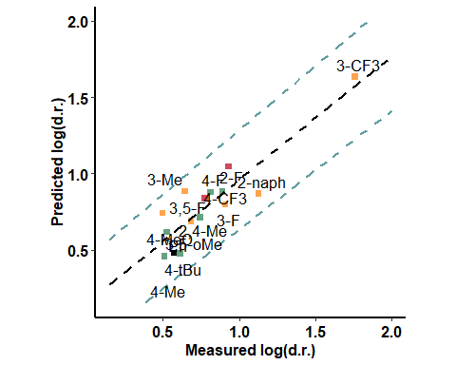

### With Catalyst - Close to the active site

|  |  |  |  |
| --- | --- | --- | --- |
| formula | R.sq | Q.sq | MAE |
| output ~ dip_x + diff.N19.H20 + B5 | 0.9110369 | 0.8371205 | 0.1031061 |

|  |  |  |  |  |
| --- | --- | --- | --- | --- |
|  | Estimate | Std. Error | t value | Pr(>|t|) |
| (Intercept) | 0.7999364 | 0.0278732 | 28.699141 | 0.00e+00 |
| dip_x | -0.2439328 | 0.0361628 | -6.745402 | 3.18e-05 |
| diff.N19.H20 | -0.2921078 | 0.0341089 | -8.563989 | 3.40e-06 |
| B5 | 0.2577144 | 0.0315807 | 8.160516 | 5.40e-06 |

***3 & 5 fold CV***

|  |  |
| --- | --- |
| Q2 | MAE |
| 0.7837803 | 0.121837 |

|  |  |
| --- | --- |
| Q2 | MAE |
| 0.8105981 | 0.1098384 |

***Top Ranked Full Model***

### With Catalyst - far

|  |  |  |  |
| --- | --- | --- | --- |
| formula | R.sq | Q.sq | MAE |
| output ~ Total + NBO.O.16 + NBO.O.18 | 0.8541393 | 0.5723166 | 0.1294332 |
| output ~ X.16.17. + Total + diff.O16.C17 | 0.8599285 | 0.5507880 | 0.1476431 |

|  |  |  |  |  |
| --- | --- | --- | --- | --- |
|  | Estimate | Std. Error | t value | Pr(>|t|) |
| (Intercept) | 0.7999364 | 0.0356903 | 22.413247 | 0.0000000 |
| Total | 0.3500325 | 0.0643050 | 5.443314 | 0.0002029 |
| NBO.O.16 | -0.2088682 | 0.0504027 | -4.143991 | 0.0016330 |
| NBO.O.18 | -0.2009904 | 0.0776564 | -2.588200 | 0.0252190 |

***3 & 5 fold CV***

|  |  |
| --- | --- |
| Q2 | MAE |
| 0.5218771 | 0.1684343 |

|  |  |
| --- | --- |
| Q2 | MAE |
| 0.5576643 | 0.1431278 |

***Top Ranked Full Model***

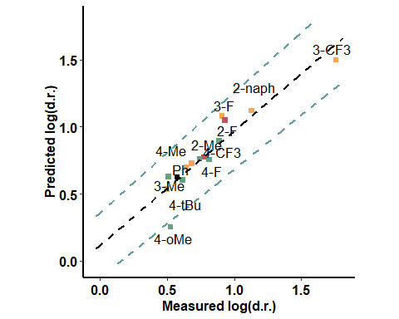

### BA + Aldehyde (pi interaction) - oxygen side

|  |  |  |  |
| --- | --- | --- | --- |
| formula | R.sq | Q.sq | MAE |
| output ~ X.1.2. + X.18.19. + NBO.H.10 | 0.8644711 | 0.6885338 | 3.846756 |
| output ~ X.2.9. + X.18.19. + NBO.H.10 | 0.8839083 | 0.6885221 | 4.566467 |

|  |  |  |  |  |
| --- | --- | --- | --- | --- |
|  | Estimate | Std. Error | t value | Pr(>|t|) |
| (Intercept) | 0.7999364 | 0.0344031 | 23.251869 | 0.0000000 |
| X.1.2. | -0.0965472 | 0.0367515 | -2.627029 | 0.0235317 |
| X.18.19. | 0.2479915 | 0.0374194 | 6.627353 | 0.0000372 |
| NBO.H.10 | 0.1216105 | 0.0376777 | 3.227650 | 0.0080488 |

***3 & 5 fold CV***

|  |  |
| --- | --- |
| Q2 | MAE |
| 0.6867888 | 5.643921 |

|  |  |
| --- | --- |
| Q2 | MAE |
| 0.6887585 | 4.541408 |

***Top Ranked Full Model***

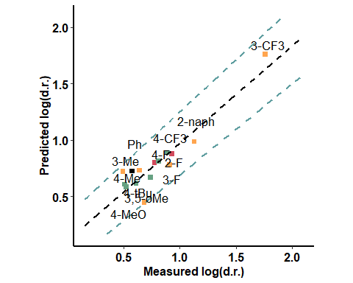

### BA + Aldehyde (pi interaction) - hydrogen side

|  |  |  |  |
| --- | --- | --- | --- |
| formula | R.sq | Q.sq | MAE |
| output ~ X.18.19. + diff.B2.O9 + B5 | 0.7091732 | 0.3900531 | 0.1979070 |
| output ~ Dist.17..18. + diff.B2.O9 + B5 | 0.6915228 | 0.3553806 | 0.1948376 |

|  |  |  |  |  |
| --- | --- | --- | --- | --- |
|  | Estimate | Std. Error | t value | Pr(>|t|) |
| (Intercept) | 0.7999364 | 0.0503963 | 15.872914 | 0.0000000 |
| X.18.19. | -0.1633268 | 0.0571441 | -2.858155 | 0.0155679 |
| diff.B2.O9 | -0.2115888 | 0.0673857 | -3.139965 | 0.0094090 |
| B5 | 0.2601548 | 0.0655114 | 3.971136 | 0.0021918 |

***3 & 5 fold CV***

|  |  |
| --- | --- |
| Q2 | MAE |
| 0.3486724 | 0.2297474 |

|  |  |
| --- | --- |
| Q2 | MAE |
| 0.3608696 | 0.209722 |

***Top Ranked Full Model***

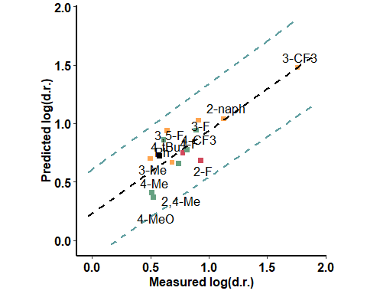

### BA + Aldehyde - H bond - aldehyde side

|  |  |  |  |
| --- | --- | --- | --- |
| formula | R.sq | Q.sq | MAE |
| output ~ Dist.18..20. + Dist.10..17. + diff.O1.B2 | 0.7811492 | 0.4855365 | 0.1775713 |
| output ~ Dist.18..20. + diff.B2.C3 + B5 | 0.7866050 | 0.4683771 | 0.1730788 |

|  |  |  |  |  |
| --- | --- | --- | --- | --- |
|  | Estimate | Std. Error | t value | Pr(>|t|) |
| (Intercept) | 0.7999364 | 0.0437175 | 18.297839 | 0.0000000 |
| Dist.18..20. | -0.4839826 | 0.0882849 | -5.482053 | 0.0001913 |
| Dist.10..17. | 1.1066412 | 0.2740859 | 4.037570 | 0.0019566 |
| diff.O1.B2 | 1.0434098 | 0.2826770 | 3.691173 | 0.0035559 |

***3 & 5 fold CV***

|  |  |
| --- | --- |
| Q2 | MAE |
| 0.4510126 | 0.1972915 |

|  |  |
| --- | --- |
| Q2 | MAE |
| 0.4635572 | 0.1871171 |

***Top Ranked Full Model***

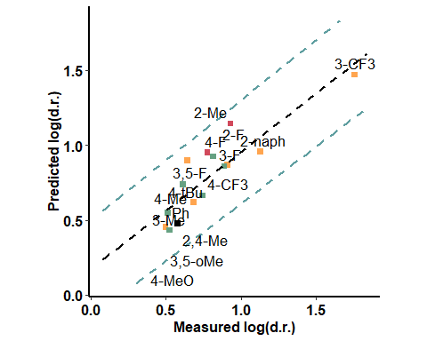

### BA + Aldehyde - H bond - opposite to aldehyde

|  |  |  |  |
| --- | --- | --- | --- |
| formula | R.sq | Q.sq | MAE |
| output ~ X.2.3. + X.17.18. + Dist.10..17. | 0.853099 | 0.7342390 | 0.1113065 |
| output ~ X.2.3. + diff.C18.H19 + B5 | 0.853946 | 0.5654389 | 0.1492731 |

|  |  |  |  |  |
| --- | --- | --- | --- | --- |
|  | Estimate | Std. Error | t value | Pr(>|t|) |
| (Intercept) | 0.7999364 | 0.0358174 | 22.333740 | 0.00e+00 |
| X.2.3. | -0.2776442 | 0.0458423 | -6.056509 | 8.23e-05 |
| X.17.18. | -0.3471624 | 0.0493848 | -7.029747 | 2.18e-05 |
| Dist.10..17. | -0.3085719 | 0.0460402 | -6.702226 | 3.37e-05 |

***3 & 5 fold CV***

|  |  |
| --- | --- |
| Q2 | MAE |
| 0.5650586 | 1.152972 |

|  |  |
| --- | --- |
| Q2 | MAE |
| 0.6649241 | 0.2985166 |

***Top Ranked Full Model***

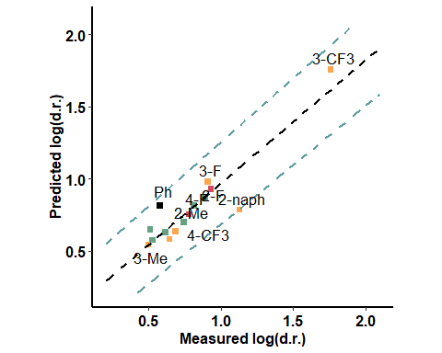

### Enamine - far from the active site

|  |  |  |  |
| --- | --- | --- | --- |
| formula | R.sq | Q.sq | MAE |
| output ~ Dist.2..3. + Total + B5 | 0.8079764 | 0.6314503 | 0.1518676 |
| output ~ para + Dist.9..16. + Total | 0.8272442 | 0.6160071 | 0.1394574 |

|  |  |  |  |  |
| --- | --- | --- | --- | --- |
|  | Estimate | Std. Error | t value | Pr(>|t|) |
| (Intercept) | 0.7999364 | 0.0409505 | 19.534241 | 0.0000000 |
| Dist.2..3. | -0.1295211 | 0.0610840 | -2.120377 | 0.0575323 |
| Total | 0.3180661 | 0.0575738 | 5.524495 | 0.0001795 |
| B5 | 0.2053727 | 0.0484404 | 4.239699 | 0.0013896 |

***3 & 5 fold CV***

|  |  |
| --- | --- |
| Q2 | MAE |
| 0.5498667 | 0.1999909 |

|  |  |
| --- | --- |
| Q2 | MAE |
| 0.5811175 | 0.1579649 |

***Top Ranked Full Model***

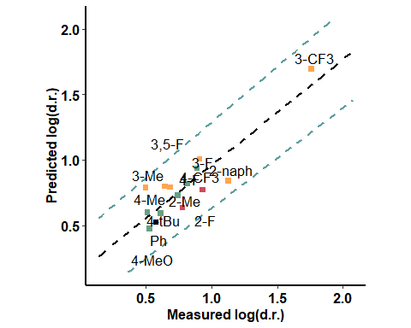

### Enamine - close to the active site

|  |  |  |  |
| --- | --- | --- | --- |
| formula | R.sq | Q.sq | MAE |
| output ~ NBO.B.2 + NBO.C.16 + diff.N24.C25 | 0.7885358 | 0.5136736 | 0.1664176 |
| output ~ X.24.25. + dip_y + NBO.C.16 | 0.7685915 | 0.4037103 | 0.2019363 |

|  |  |  |  |  |
| --- | --- | --- | --- | --- |
|  | Estimate | Std. Error | t value | Pr(>|t|) |
| (Intercept) | 0.7999364 | 0.0429734 | 18.614674 | 0.0000000 |
| NBO.B.2 | -0.2185839 | 0.0669724 | -3.263792 | 0.0075480 |
| NBO.C.16 | 0.5533003 | 0.0922491 | 5.997894 | 0.0000895 |
| diff.N24.C25 | -0.5748252 | 0.0984986 | -5.835870 | 0.0001132 |

***3 & 5 fold CV***

|  |  |
| --- | --- |
| Q2 | MAE |
| 0.451171 | 0.1922528 |

|  |  |
| --- | --- |
| Q2 | MAE |
| 0.4779782 | 0.1783278 |

***Top Ranked Full Model***

